**The Changemakers We Know: Friends, Family and Famous**

**SLC RA - Butterflies Unit - 2020**

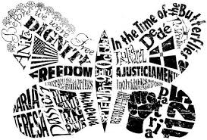

**Instructions:** Use this table to identify people you know (friends and family) and people you “know of” (famous) that you consider changemakers or revolutionaries. What’s a changemaker? A changemaker is someone who uses their voice, their actions and their influence to change something in large or small ways. Examples of famous changemakers are Malala Yousafzai, John Lewis, and RBG. Friends and family may have committed to, and/or are currently undertaking, tasks to “be the change they wish to see in the world”. They may be taking on something related to the election, they may be advocating for BIPOC rights or climate change. They may have taken a stand against oppression of others, or they may have paved the way for the rights of others. These are the changemakers we want you to identify in the table below.

| **FRIENDS or ACQUAINTANCES**  **(local heroes)**  (Name and Cause) | **FAMILY** (NAME and Cause) | **FAMOUS** (Name and Cause) |
| --- | --- | --- |
| Dave Donery |  | Greta Thunberg is famous because she is an environmental activist who is internationally known for challenging world leaders. |
| Noah Mohan and he is a local hero because he confronted the man that was causing hate crimes. |  | AOC |
| Everyone that has been protesting regarding the blm movement. |  | Alicia Keys - children's foundation |
| The mayor of fairfax barbra  coler and the mayor of san Anselmo ford greene |  | Susan B. Anthony is famous for pioneering the women's suffrage movement and women’s rights. |
|  |  | Nelson Mandela |

Group: Dessa S, Morgan S, Olivia Ramos, Emma E, Nieve T.